Review Meeting

**Contents**

Feasibility Study

Database Design

Poem Square Design

Implementation till date

Screenshots

**Feasibility Study:**

After the study of all the existing resources the following technologies are used for developing Poem Square.

**Front End**: HTML, CSS, Java Script.

**Database**: MYSQL

**Server**: XAMPP server

**Back End:** PHP

**Database Design:**

The project Poem Square requires content like images, video, audio and text to be uploaded and stored. The Database design of the poem squares is designed to store this content.

The database of the Poem Square consists of a relational table with columns

* Tile ID (Primary Key)
* Text
* Image Title
* Video Title
* Audio Title

The table has 9 rows containing tile ID’s (1-9) representing the 9 tiles in the Poem Square.

**Poem Square Design**:

The Poem Square consists of 9 tiles (3 tiles in a row). Every tile should have the following features

* Should be able to upload Text content.
* Should be able to upload Images
* Should be able to upload Videos
* Should be able to upload Audio.

The Poem Square Design has 4 icons to satisfy the features. The design also has a play button to play the content in the tile. Preview button displays the content that is uploaded in the tile. Delete button removes the tile from the Poem Square.

**Implementation till date:**

1. **Uploading Images, Videos and Audio:**

The user can upload images, videos and audio files in the tile. The

Titles of the videos are saved in the Database. A folder is created when a user uploads the files. The content is stored in the folder.

1. **Displaying the content:**

The files uploaded are stored in the folder in the project directory. The titles of the files are stored in the database. In order to display the content, the names are fetched from the database and the content is fetched from the folder and is displayed in the browser using PHP.

1. **Design of front end:**

The designing of the front end. The tile is designed with icons of text, image, video and audio. User when clicked on it a new window appears which allows the user to uploading content in to a tile.

**Screenshots**

1. **Database Design.**



1. **Database Table**.

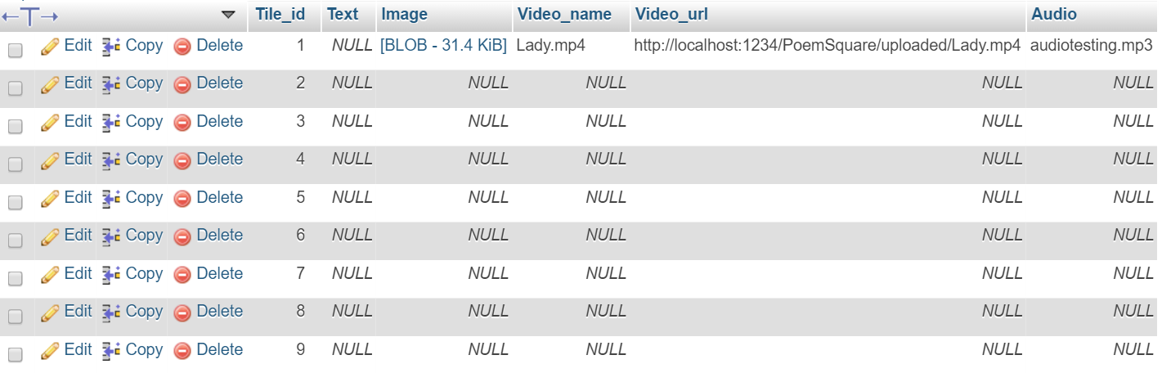

1. **Front end design of a tile**.

